Class 3 –Cycle A

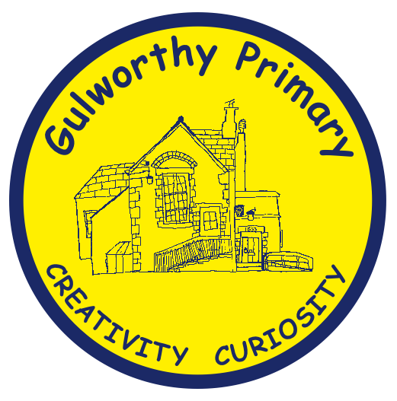 | Autumn | Spring | Summer
Science | Electricity(Y6)  Research, identifying and classifying, pattern seeking, testing, observing.  Animals including humans (Y5)  Research, observing. | Forces (Y5)  Research, identifying and classifying, pattern seeking, testing, observing. | Animal, including humans (Y6)  Research, pattern seeking, testing.  Living Things and their habitats (Y6)  Research, pattern seeking, testing.
History | Why did the ancient Maya change their way of life?  Ancient Civilisations -Pupils should be taught about a non-European society that provides contrasts with British history. | Why did Britain once rule the largest empire the world has ever seen?  A study of an aspect or theme in British history that extends pupils’ chronological knowledge beyond 1066. | What did King George VI mean when he said “The history of York is the history of Britain?”  Local Study
Geography | What is a river?  Europe including Russia United Kingdom Latitude and longitude Northern and Southern Hemisphere.  The United Kingdom.  Rivers and the water cycle Natural resources. | How do Volcanoes affect the lives of people?  Europe including Russia Latitude and longitude Northern and Southern Hemisphere and time zones.  Climate zones Volcanoes and earthquakes Settlement and land use Economic activity and trade. | Why is trade fair?  Europe including Russia South America United Kingdom Latitude and longitude Northern and Southern Hemisphere.  Climate zones Economic activity and trade Natural resources.
Art | Drawing and Painting – Leaves plants and flowers  Artist Study: Henri Rousseau | Street Art -  Artist Study: Banksy | Drawing and Sculpture(including printing) – The Seaside  Artist Study: Alfred Wallis and Hokusai
D.T. | Cams and mechanical systems Automata Systems – Design, make and evaluate  19th century designer: Joseph Faber | Textiles- Design, Make, Evaluate – Felt Phone Cases  Felt designer: Mary Anne Williams | Food and Nutrition – Design Make and Evaluate – Grab and Go  Who invented the first Calzone?
Computing | Mars Rover 1  Data Handling  Mars Rover 2  Skills Showcase | Toodlebit Unit 4  Programming  Bletchley Park  Computer systems and Networks | Programming Music  Programming  Inventing a product  Skills showcase
Music | How does music bring us together?  Orchestral, gospel.  How does music connect us with the past?  Pop, orchestral, gospel. | How does music make the world a better place?  South African, jazz, pop, orchestral.  How does music help us to get to know our community?  Reggae, orchestral, pop. | Wider Opportunities-whole class instrument tuition
R.E. | Theme: Prayer and Worship  Key Question: What is the best way for a Hindu to show commitment to god?  Religion: Hinduism  Theme: Christmas Key Question: Is the Christmas Story True?  Religion: Christianity | Theme: Hindu Beliefs  Key Question: How can Brahman be everywhere and in everything? Religion: Hinduism  Theme: Easter  Key Question: How significant is it for Christians to believe God intended Jesus to die?  Religion: Christianity | Theme: Beliefs and Moral Values  Key Question: Do beliefs in Karma, Samsara and Moksha hel Hindus lead good lives?  Religion: Hinduism.  Theme: Beliefs and practises  Key Question: What is the best way for a Christian to show commitment to God? Religion: Christianity
RSE | A world without judgement – British Values  Keeping/Staying Healthy - Alcohol | Being Responsible - Stealing  A world without judgement – Inclusions and acceptance | The Working World – Enterprise  Keeping/Staying Safe - Water Safety  - Peer Pressure  Growing and Changing
P.E. | Invasion Games  Dance  Inspirational figures: Pele, Messi, Ronaldo (Football), Anna Pavlova, Fred Astaire (dance) Anna Pavlova, Fred Astaire (dance). | Net and Wall Games  Personal goals – beat our best  Gymnastics  Inspirational figures: Simone Biles (gymnast), Serena and Venus Williams, Federer, Andy Murray (tennis). | Athletics and Swimming  Outdoor and Adventure(Y6) – Barton Hall Residential  Inspirational figures: Michael Phelps and Mark Spitz (swimming), Brian Lara (cricketer), Jesse Owens, Mo Farah, Cathy Freeman, Usain Bolt (running).
French | Phonics lessons 1 and 2  The Date  My Home | Clothes  Planets | Healthy Living  Me in the World

